Dataset Summary


2018 Final 305(b)/303(d) Assessment Unit GIS dataset. Biennially, DEQ must produce a Water Quality Assessment Integrated Report (IR) on the surface waters within the state’s jurisdiction as mandated by the Clean Water Act (CWA) sections 303(d), 305(b), and 314 and the state’s Water Quality Monitoring, Information, and Restoration Act (WQMIRA). This geographic layer is a component of the process to produce the statistics and maps shown in the IR. Data from DEQ and non-DEQ contributors collected from Jan. 1 2011 through Dec. 31 2016 was used to characterize each applicable Assessment Unit (AU) within the Commonwealth. Virginia reports on three basic water types for the IR; rivers and streams, lakes and reservoirs, and estuaries.

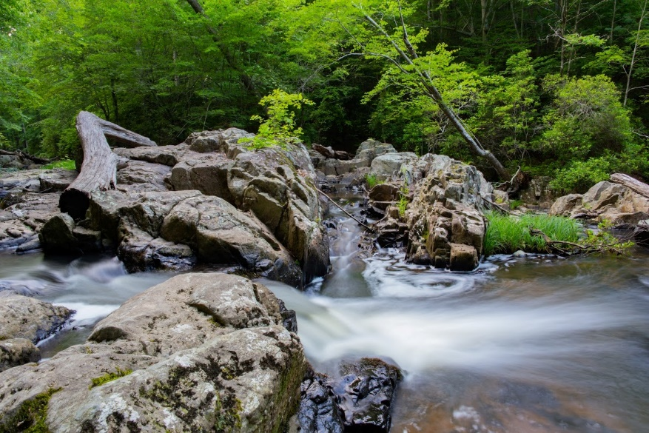
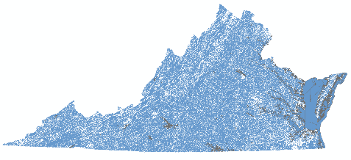

Data Highlights:
Geodatabase name: va_18ir_aus_all
> 6,762 River/Stream Assessment Units (AUs)
100,959 miles including 1,067 Fully Supporting, 2,973 Insufficient Info, and 2,722 Not Supporting (Impaired) AUs
> 255 Lake/Reservoir AUs
117,215 acres including 70 Fully Supporting, 32 Insufficient Info, and 153 Not Supporting (Impaired) AUs
> 1,325 Estuarine AUs
2,848 square miles including 82 Fully Supporting, 14 Insufficient Info, and 1,229 Not Supporting (Impaired) AUs

Dataset Description and Purpose

Display and define all surface waters identified within the 2018 305(b)/303(d) Water Quality Assessment Integrated Report. The Assessment Unit (AU) dataset was created from United States Geological Survey (USGS) National Hydrography Dataset (NHD) high-resolution 1:24,000 data extracted in September 2012. The NHD product was used by DEQ regional assessment staff to assign previously established assessment unit IDs based on predetermined up- and downstream extents and applicable Water Quality Standards. Some erroneous waters were removed and a few waters were corrected for spatial accuracy using Virginia Base Mapping Program aerial photography from Virginia Geographic Information Network (VGIN), and recent NHD data where available.

There are 3 feature classes within the geodatabase:
va_2018_aus_estuarine – estuarine waters within the commonwealth, including the Chesapeake Bay and tidal tributaries to the Bay
va_2018_aus_reservoir – lakes and reservoirs with Water Quality Standards or those monitored within the commonwealth; see appendix 7 of the IR for a complete list
va_2018_aus_riverine – free flowing surface waters within the commonwealth

This data constitutes the United States Environmental Protection Agency (EPA) approved version of the assessment unit hydrology for Virginia. Attributes assigned to each water segment are based on details associated with the ID305B (assessment unit ID) from the statewide water quality assessment database (ADB). Data validations are performed on the data prior to linking attributes to the GIS data, however errors may still occur.

Additionally, a summary dataset of water quality monitoring stations (va_18ir_wqm_stations) which includes DEQ and non-DEQ data is generated to supplement this AU data.

Please direct any questions about attribute accuracy to the Data Contact.

Resource Constraints / Use Limitations

Line work and attributes should not be altered except by the developer (DEQ). Crediting the Virginia Department of Environmental Quality as data source is requested. This data may be shared with others.

Data Contact:
Organization: Virginia Department of Environmental Quality
Name: Cleo L. Baker
Phone: 804-698-4191
Address: 1111 East Main Street, Richmond, VA 23219
Email: cleo.baker@deq.virginia.gov

Dataset Credits:
> Virginia Department of Environmental Quality, Office of Ecology, Water Monitoring and Assessment Program

Update Cycle:
> Each cycle’s data is considered static and will not be altered once the IR receives EPA approval. However, data is analyzed for a 6 year inclusive data window. That data is used to update and report on AUs for the given cycle biennially, in the even numbered year.

Data Disclaimer

This geographic information system (GIS) data is made available as a public service. This dataset is to be used for reference purposes only and Virginia Department of Environmental Quality, is not responsible for any inaccuracies herein contained. No responsibility is assumed for damages or other liabilities due to the accuracy, availability, use or misuse of the information herein provided. GIS information is in the public domain and may be copied without permission; citation of the source is suggested.
The information contained within this geospatial dataset is for reference purposes only and is not to be construed or used as a "legal description” or for legal purposes. This information is believed to be accurate, but accuracy is not guaranteed. Information drawn from this dataset must be used in consultation with appropriate federal, state, or local resource management officials. Any errors or omissions should be reported to Virginia Department of Environmental Quality via email, or via the contact listed within this Fact Sheet.

Data Quality

The geospatial product is maintained and updated by DEQ each assessment cycle (biennially) using the most current NHD product where revisions were made to Virginia waters, the most recent aerial photography provided by the Virginia Geographic Information Network (VGIN), digital topographic maps, and by freehand digitizing where necessary.

Spatial Reference Information

Native: NAD83(2011), Geographic Decimal Degrees (EPSG: 6318) https://epsg.io/6318
After Web Download: EPSG 3857: WGS 84 / Web Mercator – Spherical Mercator: https://epsg.io/3857

Data Dictionary / Field Information.

Field Name | Field Alias | Field Summary
OBJECTID |  | Auto-generated number assigned to each feature
Shape |  | Feature geometry type
ID305B | Assessment Unit ID | Unique alpha-numeric assessment unit identification code
Miles / Acres / Sq_miles | Miles / Acres / Sq_miles | Water size for the specific feature class type calculated in map units; rivers = Miles; reservoirs = Acres; estuaries = Sq_miles
CYCLE | Cycle | Current assessment reporting cycle; 2020
WATER_NAME | Water Name | Name of the water body
LOCATION | Location | Description of the location extent of the segment of water
CATEGORY | AU Category | Virginia or EPA assessment category representing the overall characterization of the water as defined in 2020 Assessment Guidance ranging from category 1 through 5R
AU_COMMENTS | AU Comments | Assessment Unit comments
IMP_CAUSE | Impairment Causes | Cause(s) of impairment to the water body
SOURCE | Sources | Suspected or confirmed sources attributed to the impairment cause(s)
AQUA_LIFE | Aquatic Life | Assessment status of the Aquatic Life Designated Use
DEEP_CHANN | Deep Channel | Assessment status of the Deep Channel (Aquatic Life) Designated Sub-Use, where applicable
DEEP_WATER | Deep Water | Assessment status of the Deep Water (Aquatic Life) Designated Sub-Use, where applicable
FISH_CONSU | Fish Consumption | Assessment status of the Fish Consumption Designated Use
MIGRATORY | Migratory | Assessment status of the Migratory Fish Spawning and Nursery (Aquatic Life) Designated Sub-Use, where applicable
OPEN_WATER | Open Water | Assessment status of the Open Water (Aquatic Life) Designated Sub-Use, where applicable
PWS | Public Water Supply | Assessment status of the Public Water Supply Designated Use, where applicable
RECREATION | Recreation | Assessment status of the Recreation Designated Use
SHELLFISH | Shellfishing | Assessment status of the Shellfishing Designated Use, where applicable
SW_SAV | Shallow Water SAV | Assessment status of the Shallow Water Submerged Aquatic Vegetation (Aquatic Life) Designated Sub-Use, where applicable
WILDLIFE | Wildlife | Assessment status of the Wildlife Designated Use
Shape_Length |  | Auto-generated length of the feature in internal units
Shape_Area |  | Auto-generated area of the feature in internal units, except for the riverine feature class where this attribute is not applicable

