Dataset Summary


2020 Final Water Quality Assessment Monitoring Stations GIS dataset. Biennially, DEQ must produce a Water Quality Assessment Integrated Report (IR) on the surface waters within the state’s jurisdiction as mandated by the Clean Water Act (CWA) sections 303(d), 305(b), and 314 and the state’s Water Quality Monitoring, Information, and Restoration Act (WQMIRA). This geographic layer is a component of the process used to supplement and support the assessment decisions made in the IR. Data from DEQ and non-DEQ contributors collected from Jan. 1 2013 through Dec. 31 2018 was used to characterize each applicable Assessment Unit (AU) within the Commonwealth.

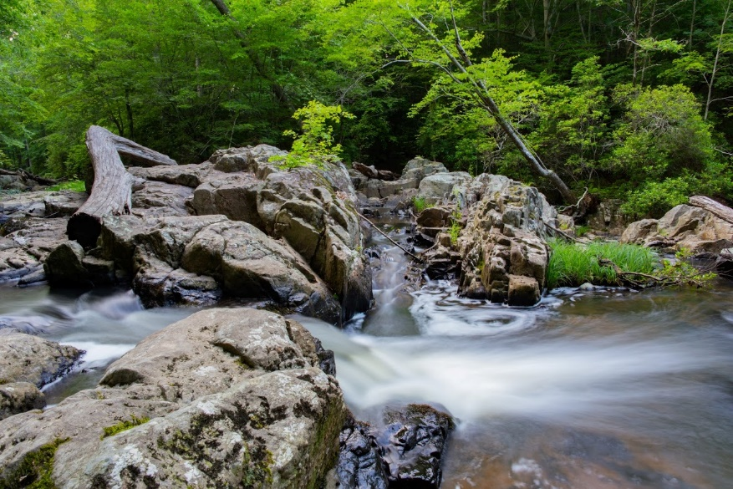
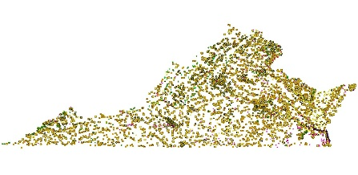

Data Highlights:
Geodatabase name: va_20ir_wqms
> 7,267 Monitoring Stations
> 5,210 River/Stream Stations
> 481 Lake/Reservoir Stations
> 1,576 Estuarine Stations
5,084 stations were used to make Fully Supporting or Not Supporting (Impaired) assessment decisions
2,719 stations were included from non-DEQ data contributors

Dataset Description and Purpose

Display and summarize monitoring data collected for and identified within the 2020 305(b)/303(d) Water Quality Assessment Integrated Report. This dataset was created from DEQ’s Comprehensive Environmental Data System (CEDS), various state, federal or local organizations, as well as many citizen monitoring groups across the commonwealth. The station data is used by regional assessment staff to assist in determining the status of the waterbody as compared to the applicable Water Quality Standards criteria set for each water.

The data represents a summary of all monitoring stations used to assess the waters represented in the IR for the 2020 assessment cycle. All points correspond to the relative position of the monitoring site as provided by DEQ staff or external data contributors. Attributes assigned to each record are aggregated over the 6 year data window for the individual station ID.

While not directly reviewed by EPA, this data constitutes the final version of this dataset to supplement the assessment hydrology layers. Attributes assigned to each water segment are based on water column, sediment, fish tissue or benthic macroinvertebrate samples collected within the given assessment data window. Data validations are performed to verify attribute and spatial accuracy, however errors may still occur.

Stations monitored prior to the 2020 IR data window may be included for clarification of assessment unit ID status but have no data within the station table’s parameter columns. See the Comments field for further information in those instances.

Please direct any questions about attribute accuracy to the Data Contact.

Resource Constraints / Use Limitations

Point locations and attributes should not be altered except by the developer (DEQ). Crediting the Virginia Department of Environmental Quality as data source is requested. This data may be shared with others.

Data Contact:
Organization: Virginia Department of Environmental Quality.
Name: Cleo L. Baker
Phone: 804-698-4191
Address: 1111 East Main Street, Richmond, VA 23219
Email: cleo.baker@deq.virginia.gov

Dataset Credits:
> Virginia Department of Environmental Quality, Office of Ecology, Water Monitoring & Assessment Program

Update Cycle:
> Each cycle’s data is considered static and will not be altered once the IR receives EPA approval. However, data is analyzed for a 6 year inclusive data window. That data is used to update and report on AUs for the given cycle biennially, in the even numbered year.

Data Disclaimer

This geographic information system (GIS) data is made available as a public service. This dataset is to be used for reference purposes only and Virginia Department of Environmental Quality, is not responsible for any inaccuracies herein contained. No responsibility is assumed for damages or other liabilities due to the accuracy, availability, use or misuse of the information herein provided. GIS information is in the public domain and may be copied without permission; citation of the source is suggested.
The information contained within this geospatial dataset is for reference purposes only and is not to be construed or used as a "legal description” or for legal purposes. This information is believed to be accurate, but accuracy is not guaranteed. Information drawn from this dataset must be used in consultation with appropriate federal, state, or local resource management officials. Any errors or omissions should be reported to Virginia Department of Environmental Quality via email, or via the contact listed within this Fact Sheet.

Data Quality

The geospatial product is maintained and updated by DEQ each assessment cycle (biennially) using all valid sample data provided that was collected within the assessment data window.
See the FGDC metadata included with the geodatabase for more information about the attribute fields.
Due to the structure and limitations of the original export and data creation in shapefile format (later converted to file geodatabase format for web use), there are numeric data fields the show a zero (0) where there is no data entered. Also, the text in the Comments field may be truncated for some records. Review Appendix 8 on the 2020 IR webpage for an Excel file (ir20_Appendix8_StationsKey-List.xlsx) which contains a code key and the list of stations with unaltered exceedance and sample values as well as the complete text of the Comments field.

Spatial Reference Information

Native: NAD83(2011), Geographic Decimal Degrees (EPSG: 6318) https://epsg.io/6318
After Web Download: EPSG 3857: WGS 84 / Web Mercator – Spherical Mercator: https://epsg.io/3857

Data Dictionary / Field Information.

Field Name | Field Alias | Field Summary
FID |  | Auto-generated number assigned to each feature
Shape |  | Feature geometry type
STATION_ID | Station ID | Station ID
ID305B_1 | Assessment Unit ID | Primary Assessment Unit assessed by the Station
ID305B_2 | Assessment Unit ID2 | Second Assessment Unit assessed by the Station
ID305B_3 | Assessment Unit ID3 | Third Assessment Unit assessed by the Station
REGION | Regional Office | DEQ Regional Office responsible for assessment evaluation
WATER_TYPE | Water Type | R = Rivers/Streams, L = Lakes/Reservoirs, E = Estuaries
SALINITY | Salinity | For stations in estuarine AUs and certain riverine segments within the Chowan Basin: S = Saltwater, TF = Tidal Freshwater, TZ = Transition Zone
LACUSTRINE | Lacustrine | For lake/reservoir AUs only: Y = Yes, sampled within the lacustrine zone, N = No, not sampled within the lacustrine zone
STA_TYPE1 | Station Type | Primary sample type: see Appendix 8 of the IR for the code list and description for each code
STA_TYPE2 | Station Type2 | Second sample type: see Appendix 8 of the IR for the code list and description for each code
STA_TYPE3 | Station Type3 | Third sample type: see Appendix 8 of the IR for the code list and description for each code
STA_TYPE4 | Station Type4 | Fourth sample type: see Appendix 8 of the IR for the code list and description for each code
STA_TYPE5 | Station Type5 | Fifth sample type: see Appendix 8 of the IR for the code list and description for each code
STA_TYPE6 | Station Type6 | Sixth sample type: see Appendix 8 of the IR for the code list and description for each code
LATITUDE | Latitude | Latitude of the station in Decimal Degrees
LONGITUDE | Longitude | Longitude of the station in Decimal Degrees
WATERSHED | Old Watershed ID | Watershed ID derived from the last 3 characters of Department of Conservation and Recreation (DCR) and United States Department of Agriculture (USDA) 14-digit hydrologic unit code developed in 1995 sometimes including water body type (R for rivers/streams, L for lakes/reservoirs or E for estuarine waters). For more information on the 14-digit codes visit https://www.dcr.virginia.gov/soil_and_water/hu.shtml.
VAHU6 | 6th Order Watershed ID | Virginia's 6th order hydrologic unit code of the National Watershed Boundary Dataset (NWBD). For more information on the 6th order codes visit https://www.dcr.virginia.gov/soil_and_water/hu.shtml.
TEMP_EXC | Temperature Exceedances | Number of Temperature Water Quality Standard Exceedances
TEMP_SAMP | Temperature Samples | Number of Temperature Samples
TEMP_STAT | Temperature Status | Temperature Assessment Status
DO_EXC | Dissolved Oxygen Exceedances | Number of Dissolved Oxygen Water Quality Standard Exceedances
DO_SAMP | Dissolved Oxygen Samples | Number of Dissolved Oxygen Samples
DO_STAT | Dissolved Oxygen Status | Dissolved Oxygen Assessment Status
PH_EXC | pH Exceedances | Number of pH Water Quality Standard Exceedances
PH_SAMP | pH Samples | Number of pH Samples
PH_STAT | pH Status | pH Assessment Status
ECOLI_EXC | E. coli Exceedances | Number of Escherichia coli (E. coli) Water Quality Standard Exceedances
ECOLI_SAMP | E. coli Samples | Number of E. coli Samples
ECOLI_STAT | E. coli Status | E. coli Assessment Status
ENTER_EXC | Enterococci Exceedances | Number of Enterococci Water Quality Standard Exceedances
ENTER_SAMP | Enterococci Samples | Number of Enterococci Samples
ENTER_STAT | Enterococci Status | Enterococci Assessment Status
WMET_EXC | Water Column Metals Exceedances | Number of Water Column Metals Water Quality Standard Exceedances
WMET_STAT | Water Column Metals Status | Water Column Metals Assessment Status
WTOX_EXC | Water Column Toxics Exceedances | Number of Water Column Toxics Water Quality Standard Exceedances
WTOX_STAT | Water Column Toxics Status | Water Column Toxics Assessment Status
SMET_EXC | Sediment Metals Exceedances | Number of Sediment Metals Water Quality Standard Exceedances
SMET_STAT | Sediment Metals Status | Sediment Metals Assessment Status
STOX_EXC | Sediment Toxics Exceedances | Number of Sediment Toxics Water Quality Standard Exceedances
STOX_STAT | Sediment Toxics Status | Sediment Toxics Assessment Status
FMET_EXC | Fish Tissue Metals Exceedances | Number of Fish Tissue Metals Water Quality Standard Exceedances
FMET_STAT | Fish Tissue Metals Status | Fish Tissue Metals Assessment Status
FTOX_EXC | Fish Tissue Toxics Exceedances | Number of Fish Tissue Toxics Water Quality Standard Exceedances
FTOX_STAT | Fish Tissue Toxics Status | Fish Tissue Toxics Assessment Status
BENTHIC_ST | Benthic Status | Benthic Macroinvertebrates Assessment Status
BIBI_SCORE | BIBI Score | Chesapeake Bay Estuarine Benthic Index of Biological Integrity Score
WOE_CAT | Weight of Evidence Category | Virginia or EPA assessment category representing the general assessment of the Aquatic Life Use for estuarine benthic communities as defined in 2020 Assessment Guidance Appendix G.
TP_EXC | Total Phosphorus Exceedances | Number of Total Phosphorus Water Quality Standard Exceedances; in Lake/Reservoir stations this number refers to the number of monitoring years exceeding the criteria
TP_SAMP | Total Phosphorus Samples | Number of Total Phosphorus Samples; in Lake/Reservoir stations this number refers to the number of monitoring years
TP_STAT | Total Phosphorus Status | Total Phosphorus Assessment Status
CHLA_EXC | Chlorophyll-a Exceedances | Number of Chlorophyll-a Water Quality Standard Exceedances; in Lake/Reservoir stations this number refers to the number of monitoring years exceeding the criteria
CHLA_SAMP | Chlorophyll-a Samples | Number of Chlorophyll-a Samples; in Lake/Reservoir stations this number refers to the number of monitoring years
CHLA_STAT | Chlorophyll-a Status | Chlorophyll-a Assessment Status
COMMENTS | Comments | Assessment comments for the monitoring station including any notes deemed relevant to explain assessment determinations
ASSESSED | Assessed | E = Evaluated, data analyzed and used to make Category 3* (Insufficient Information) determinations  N = No, no data collected within the 6 year data window, historical listing station for impairment carryover  Y = Yes, data used for Fully Supporting Category 1* or 2* or Not Supporting (Impaired) Category 4* or 5* assessment determinations
DEQ_STA | DEQ Station | Y = Yes, data collected by or on behalf of DEQ  N = No, data not collected by DEQ
MAPSTATYPE | Map Station Type | Code to group the station into one station type identifier for map display
MAP | Map Code | Major River Basin mapping code
BASIN_NM | Basin Name | Major River Basin name

